Humane Society Animal Tracking System – A Case Study

Nicholas C. DeSteffen

Kalonji Kadima

Yong Soo Jeon

Department of Mathematics and Computing
University of Wisconsin – Stevens Point
ndest964@uwsp.edu

Abstract

CIS 480 Applied Software Development Project is the Bachelor Degree’s CIS major capstone course. Students are assigned as consultant teams to real world clients to solve real world problems. Our team was given one semester to complete the analysis, design, coding, testing and installation of an operational animal tracking system for a non-profit Humane Society. The existing system was an outdated, labor-intensive DOS database system called Nutshell. Many of the reports were hand generated.
Introduction

The Humane Society has a large number of animals entering and exiting the facility on a regular basis. The staff’s current method of keeping track of animals is outdated and cumbersome. Information about each animal needs to be stored and easily retrievable. The current outdated system is no longer sufficient and needs to be replaced.

Being a retired UWSP professor and a volunteer at the Humane Society, Jack Curtis was aware of the CIS 480 course and submitted a request to have a CIS 480 team design and implement a new animal tracking system for use at the Humane Society. Our team, DeSteffen, Jeon, Kadima, was assigned to the project.

We were fortunate to be assigned this project for several reasons. The first reason is the scope of the project. The requirements were simple enough for the system to be started and completed in one semester, yet complex enough to keep everybody busy for the duration of the semester. Secondly, being that the Humane Society is a non-profit organization and likely unable to afford contracting out a project of this nature, it was good to know that our work would be directly benefiting the community in which we live.

The system being replaced is an outdated DOS based database management system called Nutshell. This system is difficult to navigate, hard to read, and requires much more work to retrieve information than is necessary. It also doesn’t store all the information needed by the Humane Society or generate all the forms and reports.

This paper will discuss the methods we used to analyze the current system, design the new system, and implement it. It will explain the requirements presented by the staff at the Humane Society, and what tools we used to design a system in which to fulfill them.

Analysis

We began the analysis phase by visiting the Humane Society and talking with the staff and the current manager, Nancy Butterfield. After talking to everybody we were able to determine the following requirements of the new system:

- Track all incoming and outgoing animals.
- Edit information about all animals.
- Track animals reported missing.
- Track animals requested.
- Track donations made.
- Handle distribution of cat and dog licenses.
- Record animal bite reports.
- Record animal complaints.
- Perform financial transactions.
- Perform basic reporting functions
- Automatically generate webpage with current animal listing

We had the staff show us their current methods of performing all the major processes. Many of the processes involved filling out lengthy forms that contained unnecessary information. Only about fifty percent of the information brought into the Humane Society was stored in their current database. What was not stored in the database was stored in binders and was often difficult to search through. There was no reliable or simple way to keep information about animals currently residing at the Humane Society up to date.

Once we had all the information about the system we mapped out all the processes performed by the system in Rational Rose. This helped us visualize all the internal and external information flows the system would need to perform.
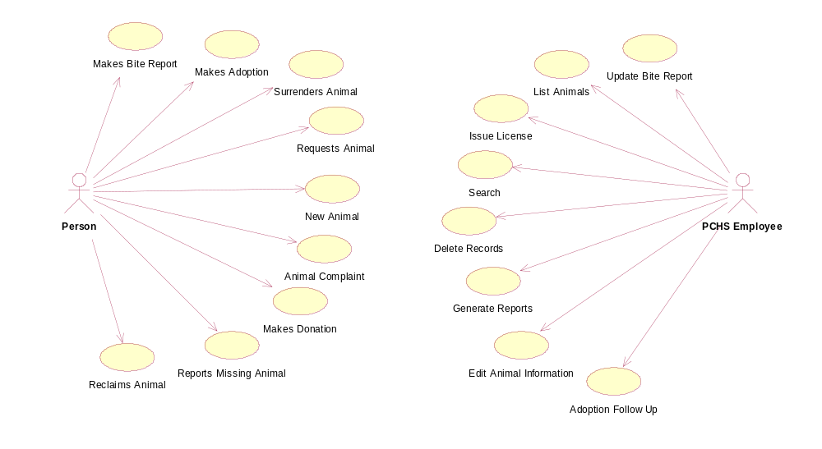
Figure 1: Humane Society Use Case Diagram

Requirements

I am now going to discuss all the requirements of the new system presented by the staff at the Humane Society in greater detail.

Track all Incoming and Outgoing Animals

When a new animal arrives at the Humane Society it must be given a classification. Four classifications were determined. Animals can be classified as stray, surrendered, abandoned, or impounded. The following information is required; the type of animal, sex, color, and approximate age. All other information, such as the animal’s temperament or vaccinations is optional and can be modified later. If an animal is surrendered, then additional information, such as its medical history and habits, is required. The original owner’s information is also entered into the system.

The whole purpose of the Humane Society is to find homes for animals. The main outgoing animal process is the adoption process. However, there are two other ways an animal can leave the system. An animal can be reclaimed if it was lost, or it can be euthanized.

The main requirement of the adoption process was to take in information about a potential adopter and store it for later verification. Once the information is verified and the adoption is approved, a contract is generated that must be fulfilled by the adopter. If the adoption is declined, then the animal goes back into the active list of animals.

An animal is reclaimed if an owner can provide proof of ownership of the animal. The owner then pays for the animal’s stay at the Humane Society. When an animal is euthanized, the staff simply changes its status to “euthanized” and it will not appear on the residing animals list anymore.

Edit information about all animals

Once an animal is in the system the staff needs a way to modify the information about the animal. Vaccinations are sometimes administered to animals and the dates that the vaccination was given needs to be recorded. Also characteristics of an animal may change, such as an animal’s temperament. The staff also needs a field to record comments about the animal.

Track Animals Reported Missing

Many times the Humane Society receives reports of missing animals. They needed a reliable way of being informed when an animal with similar characteristics is entered into the system as an animal reported missing. The system needed to notify the user that a possible match was found and display information to contact the person who reported the animal missing.

Track Animals Requested

Many times the Humane Society receives requests for animals with specific characteristics such as breed or sex. People want to be informed by the Humane Society when an animal that matches their request arrives. This requirement is very similar to the missing animal requirement. When a possible match is found the user is notified by the system and the appropriate contact information is displayed.

Track Donations Made

Donations account for a large portion of the income at the Humane Society. A means of tracking of them was another requirement. A donator can choose a specific animal to make a donation towards or they can choose to make a general donation. The system must notify the user of this at the time of the adoption if the animal has been given a donation. The donator’s information is recorded and a receipt is generated.

Handle Distribution of Cat and Dog Licenses

By state law, all cats and dogs are required to have a license that is renewed annually. This is also one of the services the Humane Society provides. The requirement was to have the system generate a license for a specific dog or cat and to be able to search for an animal’s owner based on the license number. If an animal arrives at the Humane Society with a license tag, the staff should be able to enter that number into the system, and if that license was sold at the Humane Society, then the owner’s information is displayed so they can be contacted.

Record Animal Bite Reports

Another requirement was for the system to handle animal bite reports. The Humane Society quarantines animals that have bitten somebody for a designated period of time. Documentation of the bite is something that must be recorded.

Record Animal Complaints

Many times people will call the Humane Society and complain about a neighbor’s pet. If the Humane Society receives enough complaints about a person’s animal they will try to resolve the problem. The new system must record and store information about the animal that is being a nuisance and its owner.

Perform Basic Reporting

The Humane Society needs two reports generated on a monthly basis; detailed acquisition and disposition reports, which show how each animal arrived at the Humane Society and how each animal left for a date range; and a summary report showing just the totals for each classification.

Design

I am now going to discuss the methods and tools we used to fulfill the requirements of our project.

Back End Database

The database management software we used was Microsoft Access 2000. We chose Access for two reasons. The first and foremost reason was the Humane Society already had three licenses for Microsoft Office 2000 Professional. The second reason was that we felt Access was sufficiently capable of handling the amount of data that would be stored.

The main tables in the system are the animal table and the person table. The animal table contains all the information about each animal in the system. The person table contains all the information about anybody who interfaces with the Humane Society. Nearly all other tables connect to these two tables.

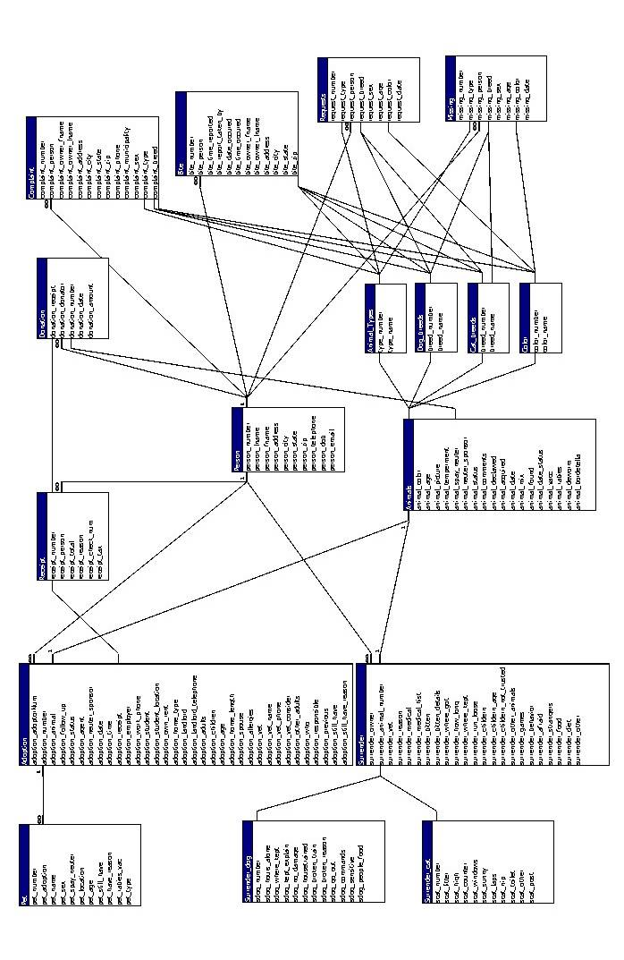

Figure 2: Database Relationships
Front End User Interface

We decided to design the user interface in Microsoft Visual Basic 6.0. Given that we only had 14 weeks to analyze, design, and implement a system we needed to use a RAD environment to fulfill all the requirements before the end of the semester. Visual Basic also integrates well with Access and is easy to learn.

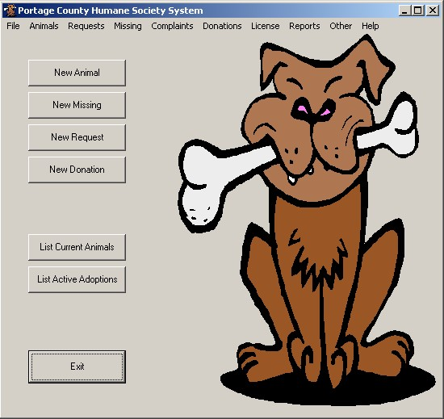

Figure 3: Main Navigation Form

Reports and Forms

We decided to use Crystal Reports 8.0 to design all the reports and forms that are generated by the system. Crystal Reports is a powerful reporting program that creates very nice looking forms and reports. We chose to use Crystal Reports over the report designer that was built into Visual Basic because the RDC in Visual Basic is difficult to use and does not have all of the capabilities that we needed in our reports and forms. Crystal Reports is also easy to learn and integrates just as well as Microsoft’s own RDC does with Visual Basic.
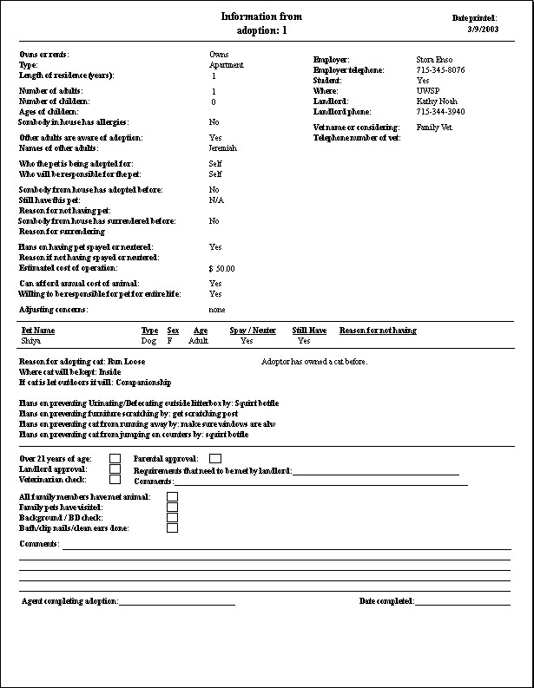

Figure 4: Adoption Verification Form
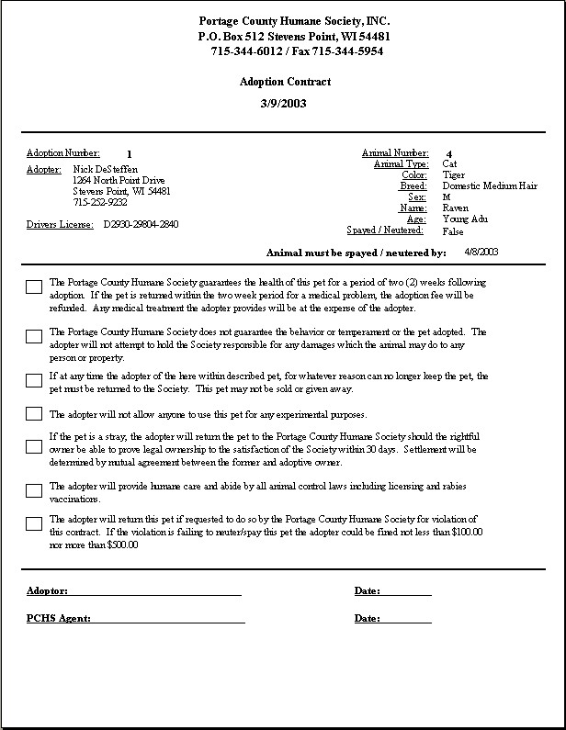

Figure 5: Adoption Contract
Web Integration

We decided to design the web portion in ASP. We used Microsoft Visual Interdev as the development environment and VBScript as the script language. VBScript is very similar to Visual Basic and is also easy to learn.

The portion of the system that is integrated with the website is the animal listing. The staff wanted to be able to select animals from the current listing and have a webpage automatically generated. Due to budget constraints, the Humane Society is unable to have a static IP address at their facility. Our solution was to have the staff locally generate a webpage from the ASP page we developed, and then post it as a regular HTML page on their current website. There will be no “live” data being posted to the internet.

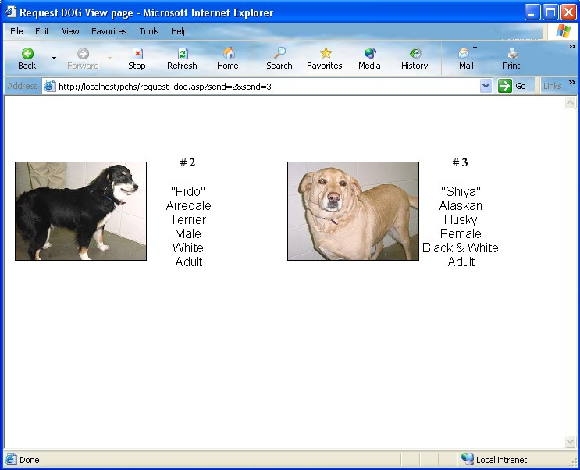

Figure 6: Automatically generated animal listing

Summary

In one fourteen week semester our team was able to design and implement a new computer system for the Humane Society. This new system not only is more detailed than its predecessor but is also more user friendly and more efficient. The reports and forms generated are easier to follow and there is less paperwork in general.

Acknowledgements

Mentor
Daniel Goulet, Professor
Department of Mathematics and Computing
University of Wisconsin – Stevens Point
Stevens Point, WI 54481
(715) 346-4916

